**

**Fire Beetle** 

**Lava Golem** 

**

**Thunder Fenrir** 

**Horned Lizards** 

**Molten Fiend** 

**

****sssOuter turret

**Cyclone eye** 

**

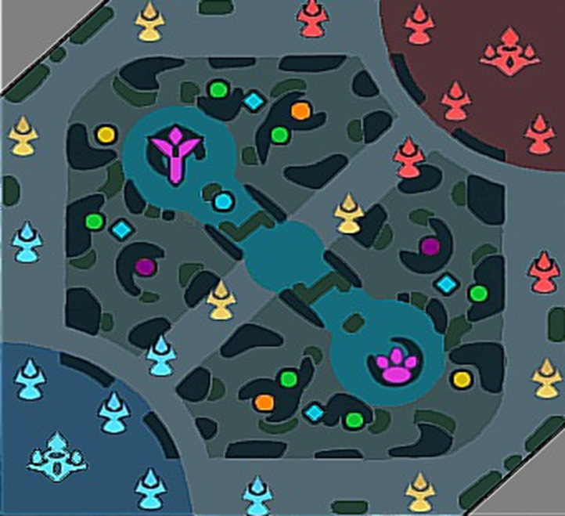

**

**

**Crab** 

**

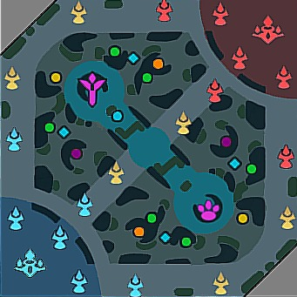

**Enemy Base**

**Bush**

**Enemy B**ase **Turret**

**Enemy B**ase **Turret**

**Enemy B**ase **Turret**

**Enemy Inner Turret**

**Enemy Inner Turret**

**Enemy Inner Turret**

**Crab**

**Enemy Outer Turret**

**Enemy Outer Turret**

**Enemy Outer Turret**

**Allie Base Turret**

**Allie Base Turret**

**Allie Base Turret**

**Allie Inner Turret**

**Allie Inner Turret**

**Allie Inner Turret**

**Allie Outer Turret**

**Allie Outer Turret**

**Allie Outer Turret**

**Horned Lizard**

**Horned Lizard**

**Thunder Fenrir**

**Thunder Fenrir**

**Crab**

**Turtle**

**Allie Base**

**Lava Golem**

**Lava Golem**

**Fire Beetle**

**Fire Beetle**

**Molten Fiend**

**Molten Fiend**

**Cyclone Eye**

**Cyclone Eye**

**Cyclone Eye**

**Cyclone Eye**

**Lithowanderer**

**Lord**